FREE WALK DRESSAGE
2522 ROUTE 207
CAMPBELL HALL, NY 10916
http://www.freewalkdressage.com

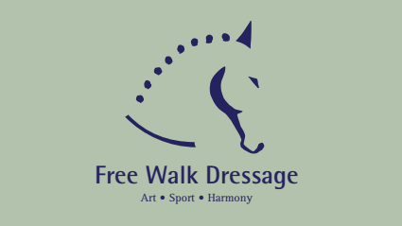

SPRING & HALLOWEEN
DRESSAGE SCHOOLING SHOW
SUNDAY APRIL 7 2019
SUNDAY OCTOBER 20 2019

OPENING DATE : March 7 /Sept 20
CLOSING DATE : April 2 / October 11

Secretary/Management :
Free Walk Dressage LLC
Madeleine Debure
2522 Route 207, Campbell Hall, NY 10916
(347) 266 5315
madeleinedebure@hotmail.com

Classes :

10A USDF Intro A
10B USDF Intro B
10C USDF Intro C
101 USEF Training Level 1
102 USEF Training Level 2
103 USEF Training Level 3
111 USEF First Level 1
112 USEF First Level 2
113 USEF First Level 3
120 USEF Second Level Test of Choice
130 USEF Third Level Test of Choice
140 USEF Fourth Level Test of Choice
150 FEI Test of Choice
160 USDF Freestyle Test of Choice
170 USDF Dressage Seat Equitation
180 WDAA Test of Choice
200 USEF/USDF Test of Choice BITLESS restricted class
300 Dressage Leadline class

Management reserves the right to cancel, split or combine classes offered.
Entries :
$25 per class
$10 office fee
$10 for late entries
$40 non-compete entry.
1 to 6 ribbons per class.
High point awards.

Write and mail check to Free Walk Dressage.
Time available Wednesday before the show on facebook or email/call (347) 266 5315 between 6pm and 8pm.
Mail or email entries with current negative coggins (within 12 months).
NO REFUND AFTER CLOSING DATE.
Refund before closing date minus Office fee.
All scores eligible towards OCDA and ESDCTA year-end awards for current members.

USE ONLY ENTRY FORM ON ESDCTA or OCDA website
Make check payable to FREE WALK DRESSAGE and send to farm address

ARENAS : if weather permits, all tests will be held on 20x60 meters sand x GGT footing outdoor ring. Entrance made from inside the ring. Warm up in indoor arena sand x GGT footing 20x56.
If heavy rain, all tests will be held in 20x56 meter ring and warm up will be arranged in the same ring in between classes and before ride.
No lunging in the rings – the only area available for lunging is in the sand paddock (stone dust), not leveled.

ASTM APPROVED HELMETS must be worn at all time when riding.

NO DOGS ALLOWED, only on leash at all times.
NO UNENTERED HORSE ALLOWED.

STALLS may be available for $25 for the day – need to clean up (not strip) ($50 deposit).

